A350 ATA36 PCE Leakage Monitoring Specification

Record of Revision
Version | Date | Author | Project Leader | Purpose of version
1.0 | 16/04/2024 | Juan Rodríguez | David Decouchon | First version

Introduction

1.1 Purpose
Several reported damages on Engine Thrust Reverser Thermal Blanket and Pylon Thermal Blanket due to PCE (pre-cooler exchanger) leaks.

The root cause is an accelerated thermal fatigue caused by additional thermal cycles due to IP-HP switchings in cruise phase not foreseen in the design phase and a PCE leakage velocity above Thermal Blanket qualification levels.

Leaks in the PCE could damage the thermal blankets.

The model objective is to detect leaky PCE by measuring the depressurization time.

1.2 Definitions

Acronym | Definition
SPM | Skywise Predictive Maintenance
PCE | Pre Cooler Exchanger
MPV | Manifold Pressure Valve
OPSOV | Over Pressure Shut Off Valve
SAV | Starter Air Valve

1.3 References

Title | Ref
ATA36 - A350 PCE leakage failures (SAR) - Monitoring | SBAOG001-8423
ATA36 - A350 PCE Leakage Monitoring Scoping Review | ATA36 - A350 PCE Leakage Monitoring Scoping Review
ATA36 - A350 PCE Leakage Monitoring Feasibility Review | ATA36 - A350 PCE Leakage Monitoring Feasibility Review
TFU - A350 PCE leaks and Thermal Blankets damages | TFU 36.11.00129

Scope

- Name of the model: PCE Leakage Monitoring
- model ID:
  - SPM: ATA36_XWB_PCE_LEAKAGE_MONITORING_M0
- ATA 4D: 3611

2.1 Applicability

- Aircraft type: XWB
- Engine type: ALL
- APU type: ALL
- Equipment FIN: 7150HA1, 7150HA2
- ATA 6D: 361162
- P/N: 67200000-02
- MOD status: N/A
- SB embodiment: N/A
- Other: The next S/W modification (not yet confirmed) will introduce a similar monitoring.

2.2 User Characteristics

Model type:
- Support
- SPM
- Requested by 1YVS, 1SYPA and SBLK

2.3 Limitations

- PCE Pressure Decay monitoring is not possible to perform during a Cross-Engine Start.
- Monitoring Window duration when the second engine starts is limited by the OPSOV and MPV opening (EBAS starts).

System Description

3.1 System Overview

- The PCE is used to reduce the temperature of engine bleed, before feeding it to the Air Generation Unit.

- If hot air leaks from PCE it can damage the other components inside the pylon.

- No active sensor is available to detect air leak from PCE.

- At the end of engine start sequence pressurized air from APU is encapsulated in closed volume between MPV, OPSOV and SAV as highlighted in purple in the system diagram below.

- PM1 sensor can be used to measure the pressure of this volume .

- Small leaks are normal because the volume is not hermetic and the pressure is reduced gradually. However, in case of leaky PCE the air pressure drops drastically.

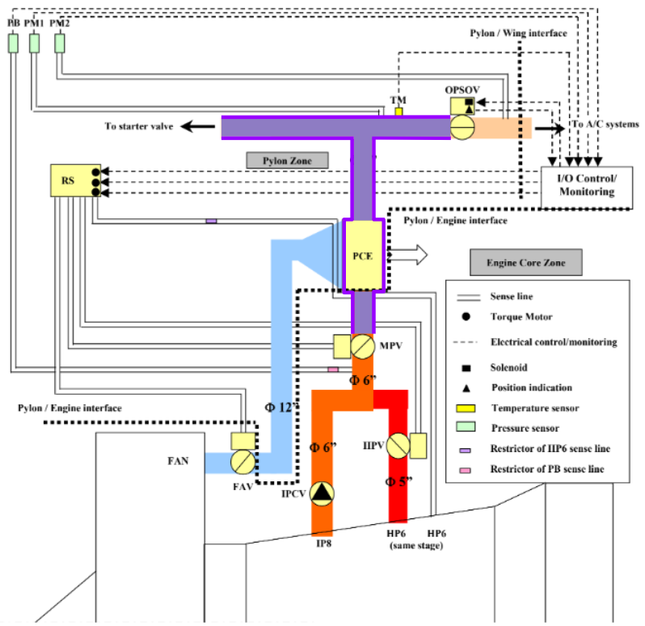

3.2 Failure mode description
Cracks in the PCE lead to faster depressurization of the air inside the volume. The air leaking from the PCE may damage the thermal blankets.
There is no Failure Message related to a leak in the PCE. The only way to confirm a leaky PCE is to perform a Leak Test to the component and check the status of the Thermal Blankets.

Model Description

4.1 External Interface Requirements

4.1.1 Data Source

Data type | Description
SAR | Channel 17

4.1.2 Input Parameters

Parameter description | Mnemonic Primary | Mnemonic Backup | Fallback | Sampling [Hz] | Interpolation mode
APU Bleed Valve Fully Closed Position | APUBVPOS:1 | APUBVPOS:2 | COMBINE_FIRST | 4 | PREVIOUS
Engine 1 running | ENGRUN.1 | Not Applicable | Not Applicable | 4 | PREVIOUS
Engine 2 running | ENGRUN.2 | Not Applicable | Not Applicable | 4 | PREVIOUS
Left Engine HP6 Pressure | HP6PR.1 | Not Applicable | Not Applicable | 4 | PREVIOUS
Right Engine HP6 Pressure | HP6PR.2 | Not Applicable | Not Applicable | 4 | PREVIOUS
OPSOV 1 Position | OPSOVPOS.1 | OPSOVPB.1 | COMBINE_FIRST | 4 | PREVIOUS
OPSOV 2 Position | OPSOVPOS.2 | OPSOVPB.2 | COMBINE_FIRST | 4 | PREVIOUS
EBAS 1 Manifold Pressure (PM1) | PM1.1 | Not Applicable | Not Applicable | 4 | PREVIOUS
EBAS 2 Manifold Pressure (PM1) | PM1.2 | Not Applicable | Not Applicable | 4 | PREVIOUS

4.2 Functional Requirements

4.2.1 Internal or Customizable Parameters

Name | Description | Min | Type
Model maturity | Maturity of the model | 1 | Internal
Model priority | Alert priority level (1: Low, 2: Medium, 3: High) | 1 | Internal
Low Leak Threshold | Minimum PCE depressurization time for low leak | 0 | Customizable
High Leak Threshold | Minimum PCE depressurization time for high leak | 0 | Customizable
Flight Window | Flight Window | 0 | Internal
Cumulative Events Threshold | Maximum number of events in a flight window | 0 | Customizable

4.2.2 Data quality checks

Check 1: All parameters available, otherwise “No Data Computed”

4.2.3 Features and logic computation

Preconditions
ALL the following conditions must be satisfied for defining the monitoring window:

- PM1 between 15 and 30 psig:
  - 15 <= PM1 <= 30
- HP6 between 20 and 80 psi and a minute ago was below 20 psi or NULL:
  - 20 < HP6 < 80
  - HP6(1 minute ago) < 20 *
- Engine running is 1 and 30 seconds ago was 0:
  - ENG_RUNNING == 1
  - ENG_RUNNING(30 seconds ago) == 0 **
- APU Bleed Valve open:
  - APU_BV_FULLY_CLOSED == 0

* If the flight data starts less than 1 minute ago, it is

Features
- depress_time_raw = monitoring window duration in seconds

- PM1_first = Value of PM1 at first point of the monitoring window

- PM1_last = Value of PM1 at last point of the monitoring window

- OPSOV_POS_first = Value of OPSOVPOS at first point of the monitoring window

- OPSOV_POS_changed = Boolean indicating if OPSOVPOS changed during the monitoring window

- pressure_drop = PM1_first - PM1_last

- depress_rate = pressure_drop / depress_time_raw

- depress_time = 15 / depress_rate

Invalid conditions

- Invalid conditions (if ANY of the following conditions is satisfied):
  - depress_rate <= 0
  - pressure_drop < 3
  - (OPSOV_POS_first == 0) & (OPSOV_POS_changed == 0)

If there is more than 1 valid depressurization event in the flight, keep only the first valid depressurization event of the flight.

If there is not any valid depressurization event in the flight, “Invalid conditions” message is triggered.

Alerting

- low_leak_event = depress_time < low_leak_threshold

- high_leak_event = depress_time < high_leak_threshold

- n_events_low = number of low_leak_event in flight_window

- n_events_high = number of high_leak_event in flight_window

- low_leak_alert: ALL following conditions must be satisfied
  - n_events_low > cumulative_events_threshold
  - high_leak_alert == FALSE

- high_leak_alert: n_events_high > cumulative_events_threshold

- Reset logic: Reset after maintenance action

4.2.4 Human Machine Interface [SPM only]

Items to be displayed

Parameter or feature reference | Accuracy | Unit
depress_time | 10⁻¹ | seconds
n_events_low | 10⁰ | flights
n_events_high | 10⁰ | flights

Performance Requirements

Performance Indicators

Expected results:
- Valid flights: >95%
- Valid flights producing alerts:
  - Low Leak Alert: 0.7%
  - High Leak Alert: 1.1%
- Spurious alerts: 0%
- Missed events: 0%

List of elements for model validation

MSN | Equipment | Event date | Event Type | Alert Date
54 | LH PCE | 13/01/2024 | Removal | 24/10/2022
39 | LH PCE | - | - | 15/03/2024
10 | RH PCE | - | - | 13/01/2024
21 | LH PCE | - | - | 20/02/2024
33 | RH PCE | - | - | 02/12/2023
47 | LH PCE | - | - | 22/11/2023
47 | RH PCE | - | - | 02/04/2024
69 | LH PCE | - | - | 25/02/2024
90 | RH PCE | - | - | 29/11/2023
132 | RH PCE | - | - | 23/11/2023
143 | LH PCE | - | - | 22/11/2023
143 | RH PCE | - | - | 22/11/2023

Results dataset for validation: alerts_pce_pressure_decay

Prototype link

Prototype Data Lineage: A350_PCE_Leakage_Monitoring_Prototype

Appendix

- MOCA: PCE Leakage Monitoring - MOCA

